

EMPLOYEE TRANSFER MANAGEMENT

Batch :
Faculty:
Group : 3
Member:

Chapter I: Problem Definition 2
Problem Abstraction 2
The Proposed System 3
❖ Solutions: 3
❖ Employee Transfer Management system 3
❖ The application allows… 3
Hardware and Software Requirements 3
❖ Minimum Requirements 3
❖ Software requirements 3
Chapter II: Customer Requirements Specification 4
Users of the System 4
❖ Project Objective: 4
❖ 2.1.1 Employee should be able to do the following: 4
❖ 2.1.2 Administrators should be able to do the following: 5
System functions 5
❖ Admin: 5
❖ Employee: 5
Chapter III. Architecture & Design of Project 6
3.1 Data Flow Diagram 6
Chapter IV. System Design 12
4.1 Database Design 12
Chapter V. GUI Screenshot 16
❖ Login 16
❖ Main Admin Interface 16
❖ Main Employee Interface 20
Chapter VI. Task Sheet 21

Chapter I: Problem Definition

Problem Abstraction
ABC Technologies Ltd. wants to develop an application for maintaining information related to its employees transfer and generating the transfer related documents. This application would be facilitating the system administrator (Higher Management) to search the employees transfer record, make new transfers and also amend the allowances offered to the employee, which usually depends on the post of the employee and the type of transfer he is getting.Currently the transfer records are maintained in the computer but there is no fixed format for.
Currently the transfer records are maintained in the computer but there is no fixed format for it. Also the information needs to be shared by releasing circulars to the respective managers and employees and other related staff members (if any).
The information though maintained on computers, entire information can not be found at single place. If higher management wants some details about the transfers, they have to get it from the respective department heads. This becomes time consuming.

The Proposed System

Solutions:
The management has decided to have a system for managing the transfers which will access a central database. This system can be installed on all the machines and the employees will have restricted access levels.
The system will have logins for employees and system administrator. And searching transfer records, updating records, making new transfers etc will be taken care of.

Employee Transfer Management system
Have 2 modules for 2 types of person:
- Administrator
- Employees

The application allows…
Application allows Employees can request for the transfer, delete, update the transfer request.
Administrators have access to manage all the information and approval for the requested transfer.
A GUI containing buttons, textboxes, labels…,
GUI containing buttons, textboxes, labels…, which will provide an user-friendly interface to the user to work with the application

Hardware and Software Requirements

Minimum Requirements
- 512 Megabytes of RAM or higher
- Pentium IV or higher capability CPU
- Windows 2000 (or higher if possible)
- Java Virtual Machine

Software requirements
- Java SE 5.0.
- NetBeans 5.5.
- MS SQL Server 2005
- JDBC, ODBC Driver

Chapter II: Customer Requirements Specification

Users of the System

Project Objective:
- Users are Employee and Administrators.
- Creating a database general for users, employees and administrators to distinguish by role.

2.1.1 Employee should be able to do the following:
- Employees can view, search transfer records of individuals and update, delete transfer records has not been approved.
- Employees can request for the transfer.
- Employees can view and search for some personal information

2.1.2 Administrators should be able to do the following:
- Add information of employee
- Save/Edit any information of employees.
- Delete any employee. Before deleting a warning should be displayed so as to confirm and after deleting display message about deletion
- The Administrators should be able to search a employee by name.
- While adding/editing a Employee only required buttons should be enabled.
- Create, delete transfer records and approved transfer record.
- Generate the allowances; the employee will be entitled for based on the transfer location and his post.
- Generate transfer letters.
- Generate various reports like employees transferred in particular month / time span, transfers happened for particular projects etc.

System functions

Admin:
Login, search, Manage information of employees, manage transfer records, manage location, manage project, manage department.
- Login:
  - Input: User and password.
  - Process: Check valid data input. Check to be in being of user’s account in database Users table.
  - Output: if enter the correct notification is successful. If entered incorrectly request in again.
- Change password:
  - Input: Old user and password , new password.
  - Process: Check valid data input. update new password in the database Users table.
  - Output: Display notification.

- Search:

- Employee:
- Input: Name or employee ID
- Process: Check valid data input. Check employee in database Employees table.
- Output: if exist in database show information search, else message error.
- Transfer request:
- Input: Employee’s name or current location, current project, current department or Transfer Relieving Date, Transfer Joining Date.
- Process: Check valid data input. Check data in database Transfers table.
- Output: if true enter the GUI from else message error.

- Location:
      - Input: Location’s name.
      - Process: Check valid data input. Check location in database Locations table.
      - Output: if true enter the GUI from else message error.

- Project:
      - Input: Project’s name.
      - Process: Check valid data input. Check project in database Projects table.
      - Output: if true enter the GUI from else message error.
- Department:
      - Input: Department’s name.
      - Process: Check valid data input. Check department in database Departments table.
      - Output: if true enter the GUI from else message error.
- Approval:
      - Input: select transfer request and input transfer joining date,…
      - Process: Check valid approval and update data in database table : Transfer, Transfer Detail, Employee. And submit transfer letter to employee.
      - Output: if true enter the GUI from else message error.

- Location Management: add, edit, delete.
- Add:
        - Input: location’s name.
        - Process: Insert location’s name to database.
        - Output: Message successful or Message error.
- Edit:
  - Input: Location’s name.
  - Process: Update location’s name to database.
  - Output: Message successful or Message error.
- Delete:
        - Input: Location id.
        - Process: Check exist location id, alert to ask before delete, delete location from database.
        - Output: Message successful or Message error.

- Project Management: add, edit, delete.
- Add:
        - Input: Project’s name.
        - Process: Insert project’s name to database.
        - Output: Message successful or Message error.
- Edit:
  - Input: Project’s name.
  - Process: Update project’s name to database.
  - Output: Message successful or Message error.
- Delete:
        - Input: Project id.
        - Process: Check exist project id, alert to ask before delete, delete project from database.
        - Output: Message successful or Message error.

- Department Management: add, edit, delete.
- Add:
        - Input: Department’s name.
        - Process: Insert department’s name to database.
        - Output: Message successful or error.
- Edit:
  - Input: Department’s name.
  - Process: Update department’s name to database.
  - Output: Message successful or error.
- Delete:
        - Input: Department id.
        - Process: Check exist department id, alert to ask before delete, delete department from database.
        - Output: Message successful or error.

- Transfer Record Management: add, edit, delete, report
- Add:
  - Input: Transfer record’s information.
  - Process: Insert Transfer record’s information to database.
  - Output: Message successful or error.
- Edit:
  - Input: Transfer record’s information.
  - Process: Update Transfer record’s information to database.
  - Output: Message successful or error.
- Delete:
        - Input: Transfer record id.
        - Process: Check exist transfer record id, alert to ask before delete, delete transfer record from database.
        - Output: Message successful or error.
- Report:
- Input: From date , to date
- Process: Check valid data input. Check data in database Transfers table.
- Output: if true enter the GUI from else message error.
- Employee Management: add, edit, delete.
- Add:
  - Input: employee’s information.
  - Process: Insert employee’s information to database.
  - Output: Message successful or error.
- Edit:
- Input: employee’s information.
- Process: Update employee’s information to database.
- Output: Message successful or error.
- Delete:
        - Input: employee id.
        - Process: Check exist employee id, alert to ask before delete, delete employee from database.
        - Output: Message successful or error.

Employee:
- Login:
      - Input: user and password.
      - Process: Check valid data input. Check to be in being of user’s account in database – employee table.
      - Output: if true enter the GUI from else message error.
- Change password:
  - Input: Old user and password , new password.
  - Process: Check valid data input. update new password in the database Employee table.
  - Output: Display notification
- Transfer Request:
- Input: Information Request Transfer
- Process: Insert Information Request Transfer to database.
- Output: Message successful or error.
- Request transfer Management (pending approval):
- Edit:
        - Input: Information Request Transfer.
        - Process: Update Information Request Transfer to
database.
        - Output: Message successful or error.
- Delete:
        - Input: Request Transfer id.
        - Process: Check exist Request Transfer id, alert to ask before delete, delete Request Transfer from database.
        - Output: Message successful or error.

Chapter III. Architecture & Design of Project

3.1 Data Flow Diagram
Since the application will have a three – tier architecture

Figure 1: DFD LEVEL 0 - Context Diagram
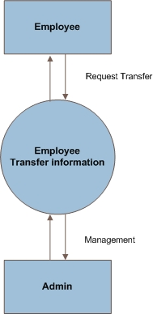

Figure 2: DFD LEVEL 1 – Application process
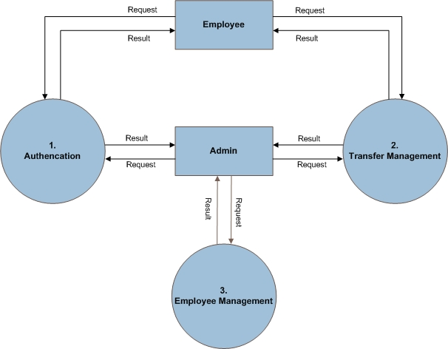

Figure 3: DFD Level 1.1. Login Admin - Level 1.2. Change password Admin
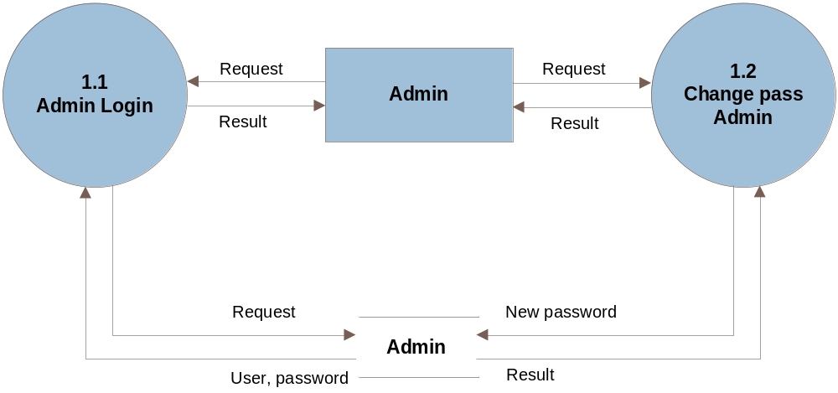

Figure 4: DFD Level 1.3. Login Employee - Level 1.4. Change password Employee
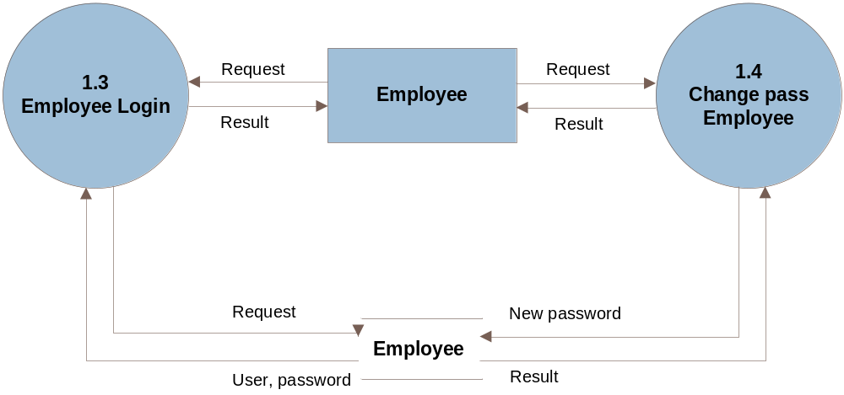

Figure 5: DFD Level 2.1. Search
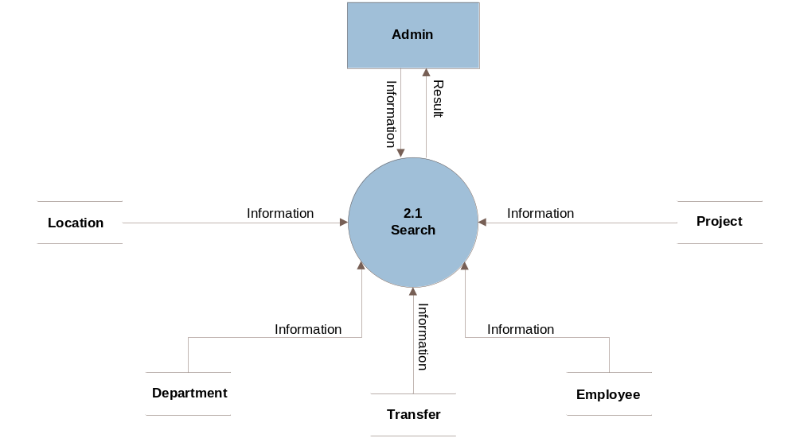

Figure 8: DFD Level 2.2.Approval

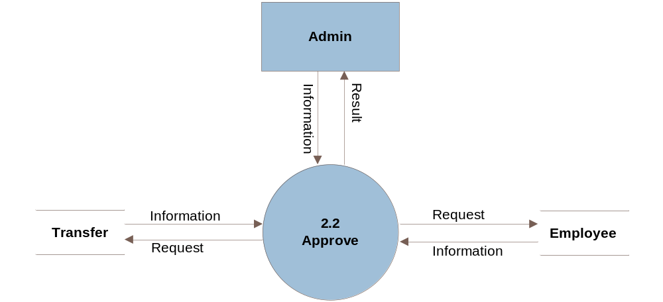

Figure 9: DFD Level 2.3.Location management - Level 2.4. Project management
– Level 2.5. Department management
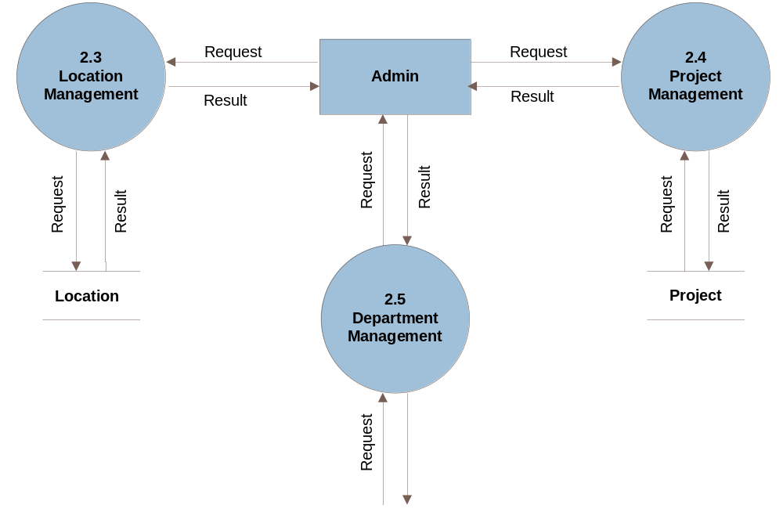

Figure 12: DFD Level 2.6. Transfer request management admin
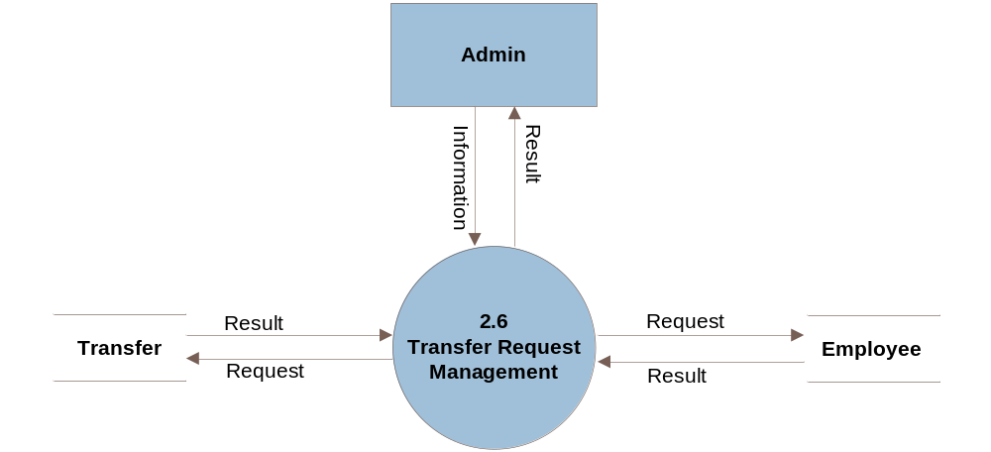
Figure 13: DFD Level 2.7. Transfer request management employee
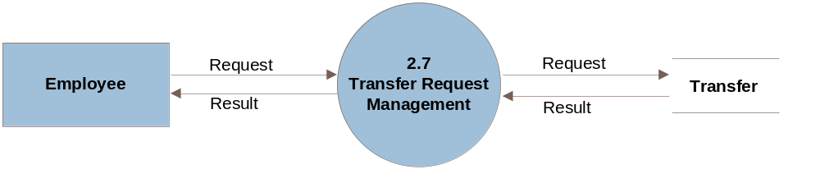
Figure 14: DFD Level 3.1. Employee management

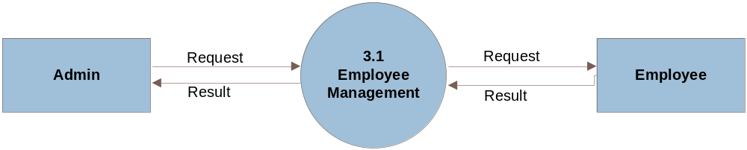

Chapter IV. System Design

4.1 Database Design

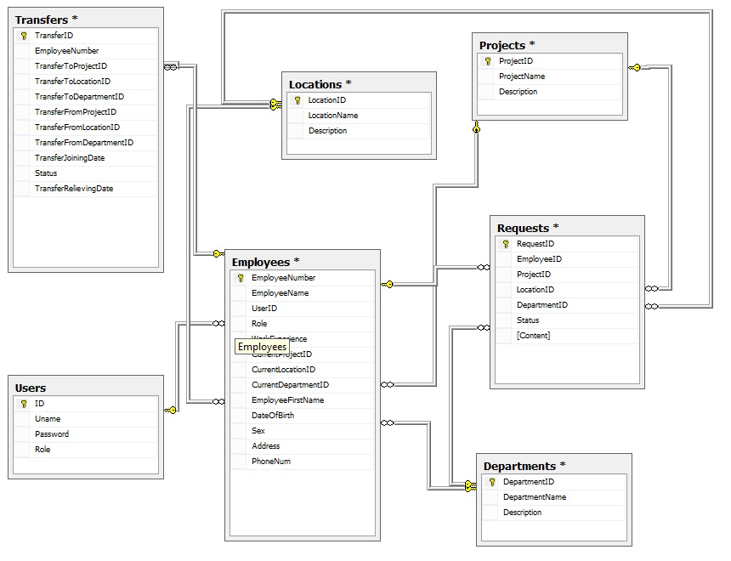

- Table Users

Field Name | Data Type | Allow Null | Key | Description
ID | int | Not null | PK | Store User ID
Uname | varchar(25) | Not null |  | Store user name
Password | varchar(32) | Not null |  | Store password
Role | bit | Not null |  | Store role

- Departments
Field Name | Data Type | Allow Null | Key | Description
DepartmentID | int | Unchecked | PK | Store Department ID
DepartmentName | varchar(50) | Checked |  | Store DepartmentName
Description | varchar(50) | Checked |  | Store Description

- Employees
Field Name | Data Type | Allow Null | Key | Description
EmployeeNumber | int | Unchecked | PK | Store Employee ID
EmployeeName | varchar(15) | Unchecked |  | Store Employee Name
UserID | int | Checked |  | Store user id
Role | varchar(50) | Checked |  | Store role
WorkExperience | text | Checked |  | Store work Exeprience
CurrentProjectID | int | Checked |  | Store Project ID
CurrentLocationID | int | Checked |  | Store Location ID
CurrentDepartmentID | int | Checked |  | Store Department ID
EmployeeFirstName | varchar(15) | Checked |  | Store First name
DateOfBirth | date | Checked |  | Store birthday
Sex | bit | Checked |  | Store Gender
Address | text | Checked |  | Store address
PhoneNum | varchar(15) | Checked |  | Store phone

- Table Location

Field Name | Data Type | Allow Null | Key | Description
LocationID | int | Unchecked | PK | Store Location ID
LocationName | varchar(50) | Checked |  | Store Location Name
Description | varchar(50) | Checked |  | Store Description

- Table Projects

Field Name | Data Type | Allow Null | Key | Description
ProjectID | int | Unchecked | PK | Store Project ID
ProjectName | varchar(50) | Checked |  | Store Project name
Description | varchar(50) | Checked |  | Store create description

- Table Transfers

Field Name | Data Type | Allow Null | Key | Description
TransferID | int | Unchecked | PK | Store Transfer ID
EmployeeNumber | int | Checked |  | Store Employee ID
TransferToProjectID | int | Checked |  | Store ToProjectID
TransferToLocationID | int | Checked |  | Store ToLocationID
TransferToDepartmentID | int | Checked |  | Store ToDepartmentID
TransferFromProjectID | int | Checked |  | Store FromProjectID
TransferFromLocationID | int | Checked |  | Store FromLocationID
TransferFromDepartmentID | int | Checked |  | Store FromDepartmentID
TransferJoiningDate | date | Unchecked |  | Store Joiningdate
Status | bit | Unchecked |  | Status
TransferRelievingDate | date | Unchecked |  | Store TransferRelie

- Table Requests
Field Name | Data Type | Allow Null | Key | Description
RequestID | int | Unchecked | PK | Store Request ID
EmployeeID | int | Checked |  | Store Employees ID
ProjectID | int | Checked |  | Store Project ID
LocationID | int | Checked |  | Store Location ID
DepartmentID | int | Checked |  | Store Department ID
Status | bit | Checked |  | Status
[Content] | text | Checked |  | Store Content

Chapter V. GUI Screenshot

Login
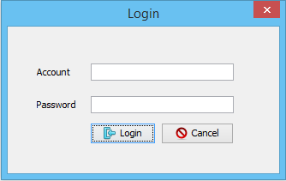
Change pass
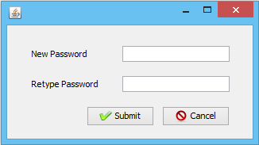

Main Admin Interface
List employee tab
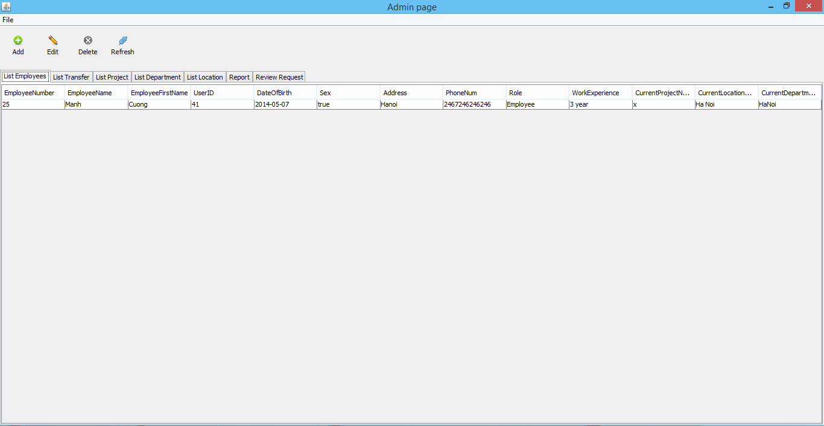

List transfer tab
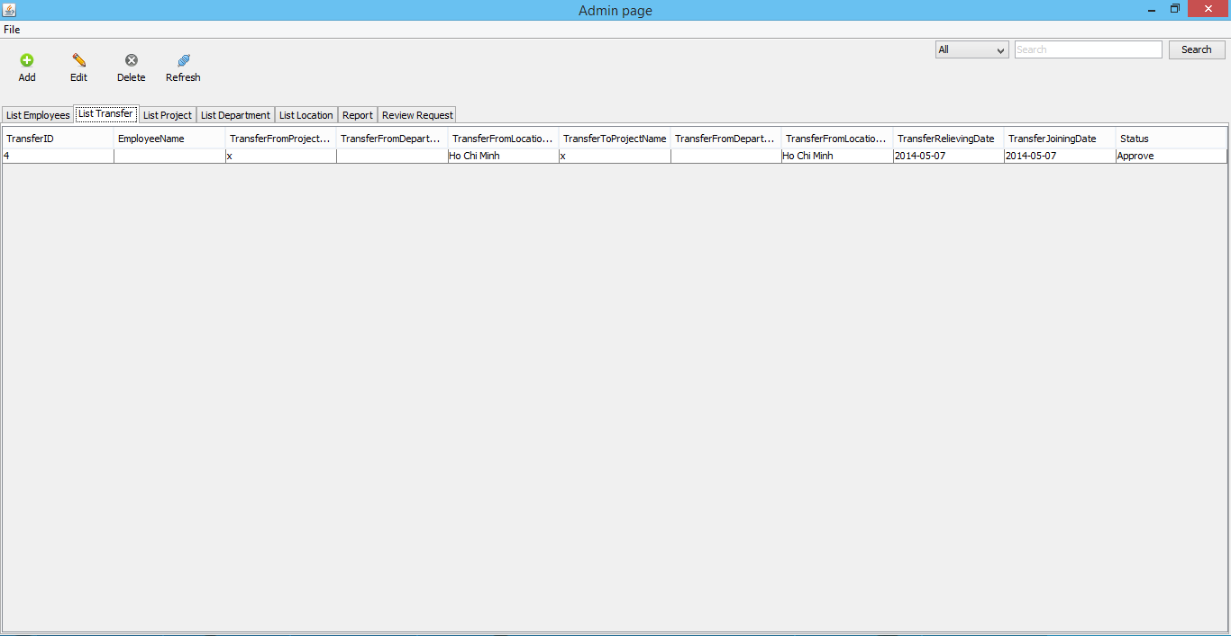

List project tab
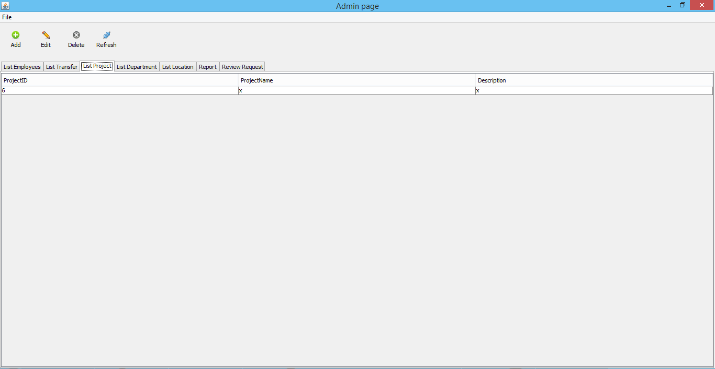

List Department tab
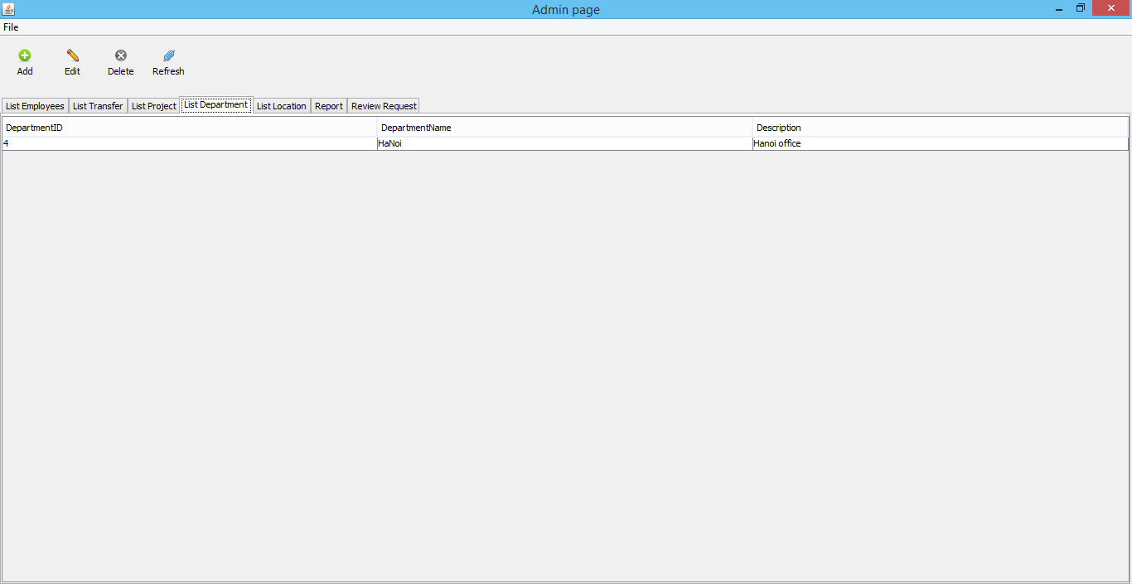

List Location tab
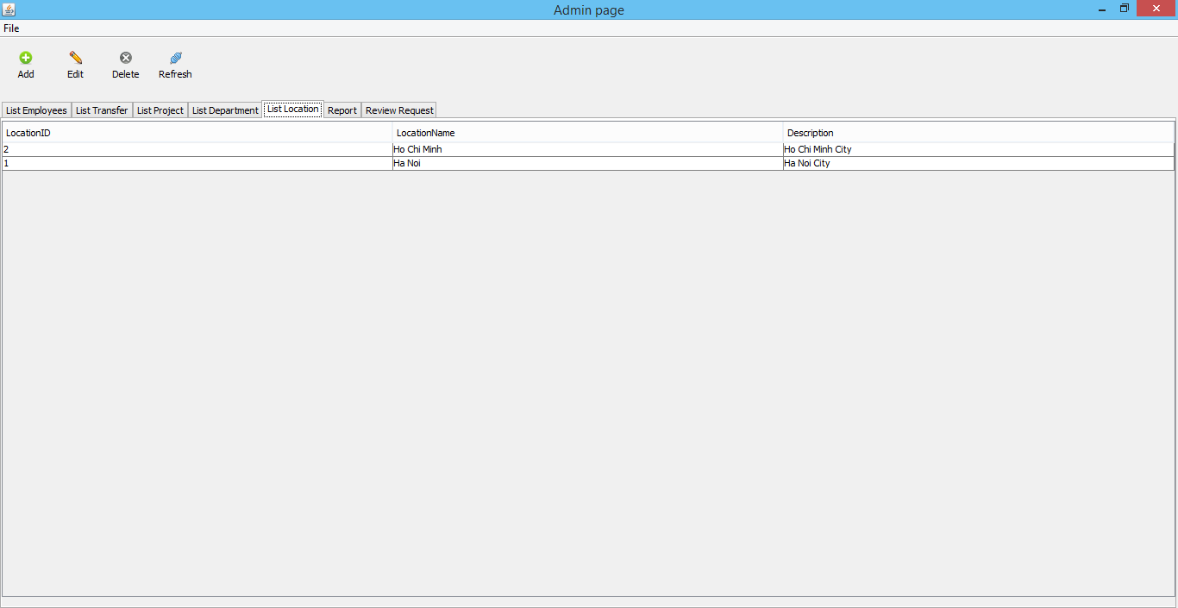

Report tab
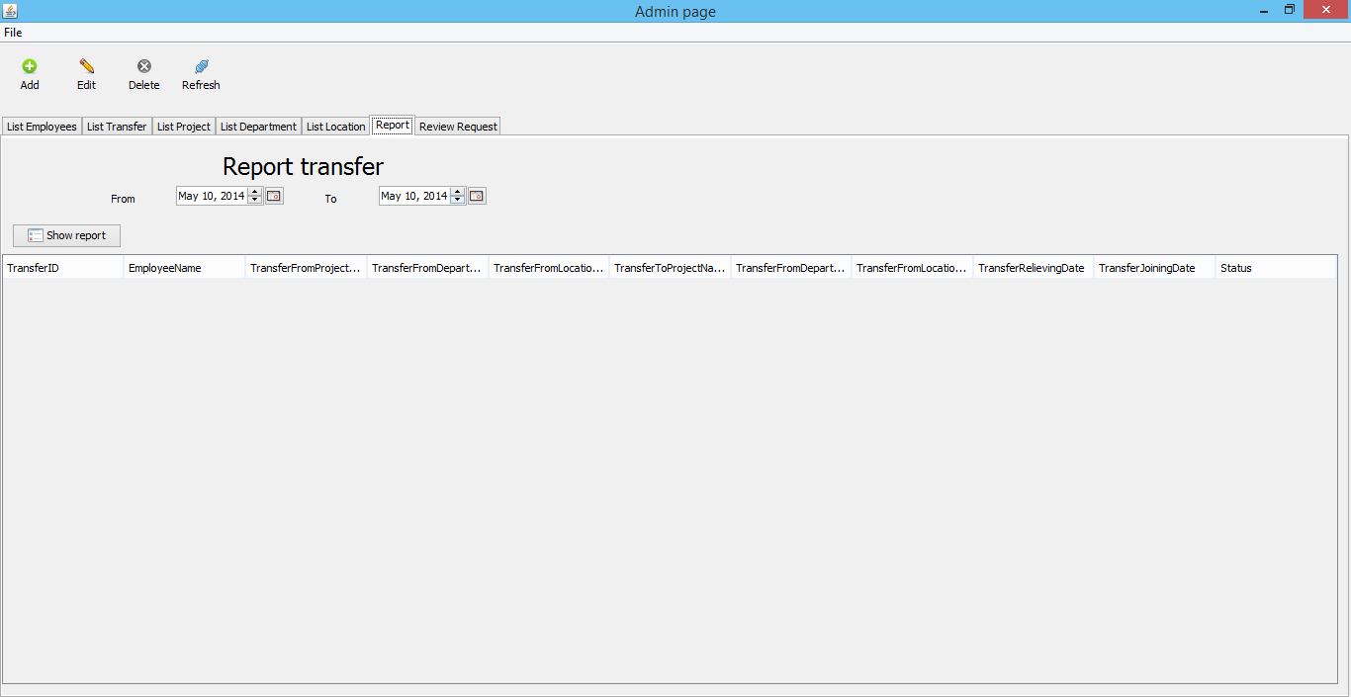

Review request tab
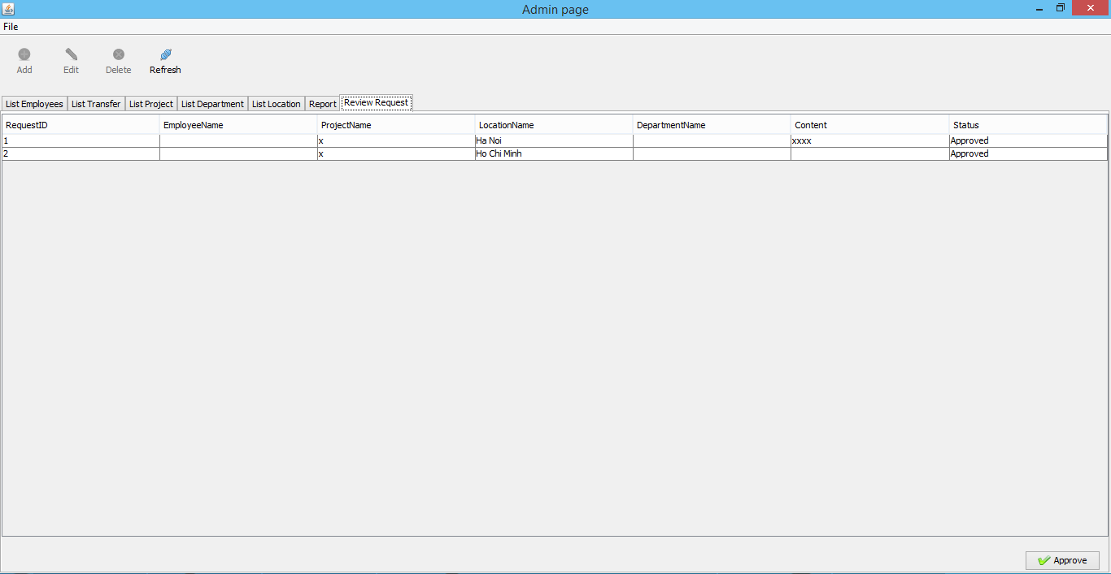

Main Employee Interface
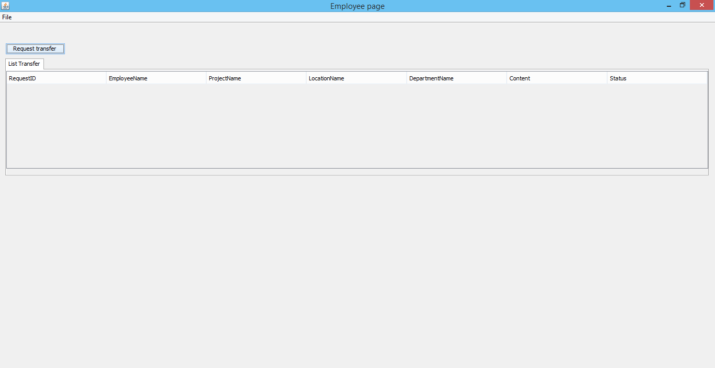

Chapter VI. Task Sheet

SR. No. | Task | Date of Preparation of Activity Plan: 04/10/2014
SR. No. | Task | Start Date | Finish Date | Team Member Names | Status
Document
1 | Problem Definition | 04/10/2014 | 04/11/2014 |  | Completed
2 | Customer Requirements Specification | 04/12/2014 | 04/14/2014 |  | Completed
3 | DFD  ERD | 04/12/2014 | 04/25/2014 |  | Completed
4 | Table Design | 04/12/2014 | 04/25/2014 |  | Completed
5 | Mocks UI | 04/12/2014 | 04/25/2014 |  | Completed
Code
1 | Login  Logout  Database Config | 04/04/2014 | 04/24/2014 |  | Completed
2 | Change Password | 04/04/2014 | 04/24/2014 |  | Completed
3 | Employee Manager | 04/05/2014 | 04/27/2014 |  | Completed
4 | Project Manager | 04/07/2014 | 04/27/2014 |  | Completed
5 | Location Manager | 04/05/2014 | 04/05/2014 |  | Completed
6 | Department Manager | 04/08/2014 | 04/19/2014 |  | Completed
7 | Transfer Process | 04/24/2014 | 04/28/2014 |  | Completed
8 | Review Request | 04/24/2014 | 04/28/2014 |  | Completed
10 | Search | 05/06/2014 | 05/10/2014 |  | Completed
11 | Report | 05/09/2014 | 05/10/2014 |  | Completed

